

**Business Analytics with Power BI**

Student Lab Manual – Lab 2 – Power BI Service

Version 1.0

**Conditions and Terms of Use**

**Microsoft Confidential**

This training package is proprietary and confidential, and is intended only for uses described in the training materials. Content and software is provided to you under a Non-Disclosure Agreement and cannot be distributed. Copying or disclosing all or any portion of the content and/or software included in such packages is strictly prohibited.

The contents of this package are for informational and training purposes only and are provided "as is" without warranty of any kind, whether express or implied, including but not limited to the implied warranties of merchantability, fitness for a particular purpose, and non-infringement.

Training package content, including URLs and other Internet Web site references, is subject to change without notice. Because Microsoft must respond to changing market conditions, the content should not be interpreted to be a commitment on the part of Microsoft, and Microsoft cannot guarantee the accuracy of any information presented after the date of publication. Unless otherwise noted, the companies, organizations, products, domain names, e-mail addresses, logos, people, places, and events depicted herein are fictitious, and no association with any real company, organization, product, domain name, e-mail address, logo, person, place, or event is intended or should be inferred.

**Copyright and Trademarks**

© 2016 Microsoft Corporation. All rights reserved.

Microsoft may have patents, patent applications, trademarks, copyrights, or other intellectual property rights covering subject matter in this document. Except as expressly provided in written license agreement from Microsoft, the furnishing of this document does not give you any license to these patents, trademarks, copyrights, or other intellectual property.

Complying with all applicable copyright laws is the responsibility of the user. Without limiting the rights under copyright, no part of this document may be reproduced, stored in or introduced into a retrieval system, or transmitted in any form or by any means (electronic, mechanical, photocopying, recording, or otherwise), or for any purpose, without the express written permission of Microsoft Corporation.

For more information, see Use of Microsoft Copyrighted Content at

<http://www.microsoft.com/en-us/legal/intellectualproperty/Permissions/default.aspx>

DirectX, Hyper-V, Internet Explorer, Microsoft, Outlook, OneDrive, SQL Server, Windows, Microsoft Azure, Windows PowerShell, Windows Server, Windows Vista, and Zune are either registered trademarks or trademarks of Microsoft Corporation in the United States and/or other countries. Other Microsoft products mentioned herein may be either registered trademarks or trademarks of Microsoft Corporation in the United States and/or other countries. All other trademarks are property of their respective owners.

Lab 2 – Power BI Service

# Lab 2: Power BI Service

### Introduction

In this lab, you will create a Microsoft Power BI dashboard to report on the US sales activities. This will involve uploading the **US Sales Analysis.pbix** file created with Power BI Desktop.

You will then assemble the dashboard layout with tiles sourced from the Q&A questions, and new, and existing report visualizations.

The final dashboard will look similar to the following screenshot.

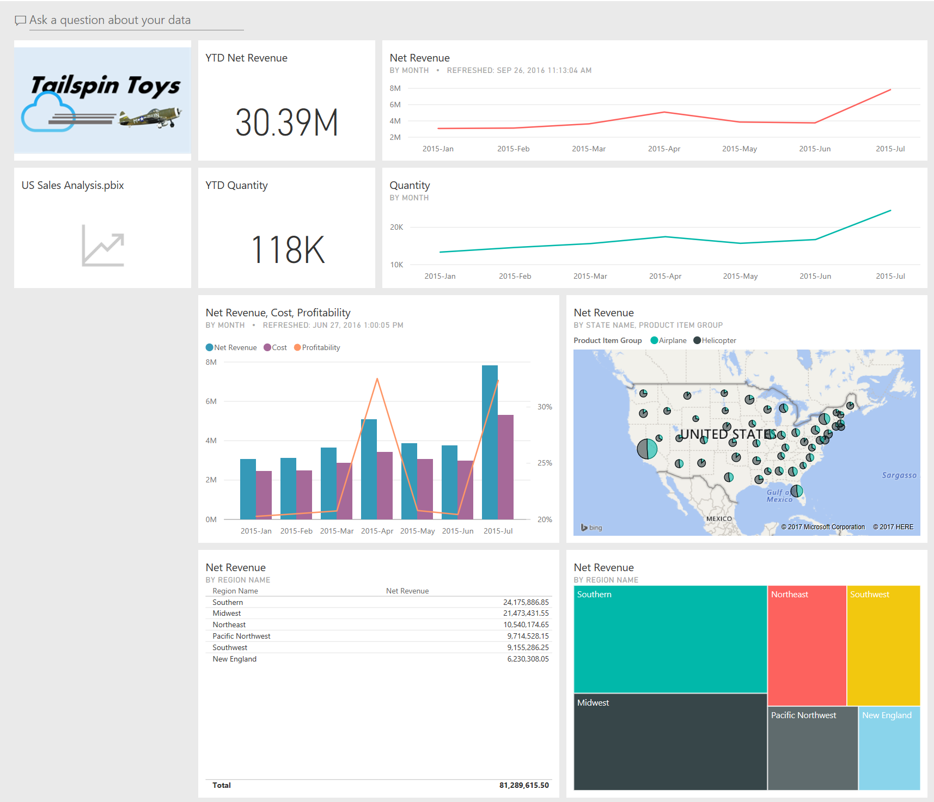

### Objectives

After completing this lab, you will be able to:

* Sign in to Power BI.
* Create a dataset by uploading a Power BI Desktop file.
* Assemble a dashboard consisting of tiles.
* Use the Q&A questions to create dashboard tiles.
* Use the existing report visualizations to create dashboard tiles.
* Use the new report visualizations to create dashboard tiles.

### Estimated time to complete this lab

1 hour (depends on experience)

### Resources

|  |  |
| --- | --- |
| VM Name | Business Analytics with Power BI - Module 1 |
| Domain | POWERBI-WIN10 |
| User | POWERBI-WIN10\LabUser |
| Password | P@ssw0rd1! |
| Lab Files | E:\Labs\ |

# Exercise 1: Signing-in to Power BI

### Introduction

In this task, you will sign in to Power BI, or sign-up for the service if you have not done so in the past.

Note that you only need to sign up once, for a particular email account.

### Objectives

* Sign in or sign up to Power BI

### Signing in to Power BI

1. To open Microsoft Internet Explorer, on the taskbar, right-click the **Microsoft** **Edge (Internet Explorer)** program shortcut.



1. In Internet Explorer, navigate to http://powerbi.com.
2. Click **Sign In** (located at the top right corner).



1. Enter your email address and password, and then select the **Keep Me Signed In** check box.



1. Click **Sign In**.



1. Leave the Internet Explorer window open.

### Creating a Power BI Account

In this task, you will sign up for Power BI.

*Note: Do not complete this task if you have already registered and signed in to Power BI, before.*

1. To open Internet Explorer, on the taskbar, click the **Internet Explorer** program shortcut.
2. In Internet Explorer, navigate to <https://powerbi.microsoft.com/en-us/get-started/> .
3. Scroll down and select the option TRY FREE:

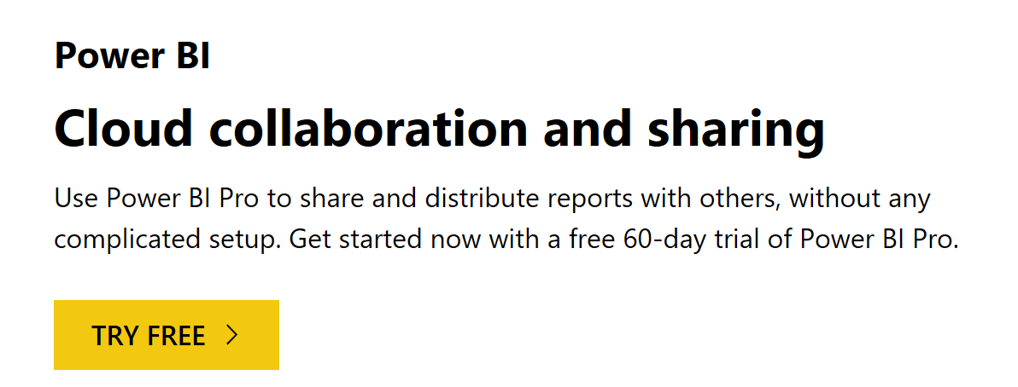

*Note: Certain circumstances may prevent you from signing up for a Power BI account. If you cannot sign up, in Internet Explorer, navigate to Self-Service Signup for Power BI and use a workaround appropriate to your circumstances.*

1. Insert your organizational e-mail and press Enter
2. When prompted, to complete the sign up and to agree to the terms and conditions, click **Continue**.
3. When prompted, click **Start**.

*Note: The account may take up to five minutes to be created. When the account has been created, you will be directed to the Microsoft Power BI site.*

1. When the **Microsoft Power BI** site page loads, in the **Welcome** dialog box, click **Get Started**.
2. Leave the Internet Explorer window open.

### Upgrade your account

1. To upgrade the trial account to the **Power BI Pro** trial license, at the top right corner, click the **Settings** command (cog), and then select **Manage Personal Storage**.

You only need to do this if you see 1GB available. If you see 10 GB, you already have a Pro license.

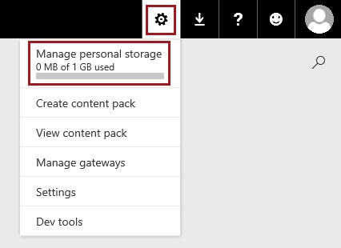

1. At the top right corner, click **Try Pro for Free. NOTE: You do not need PRO features to complete the lab**.



1. In the dialog box, if you agree to the terms, select the check box.

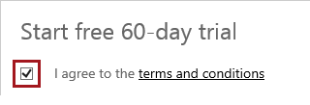

1. Click **Try Power BI Pro**.

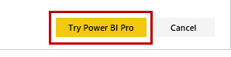

1. When the trial extension has been confirmed, click **Close**.
2. To navigate to your workspace, click the Power BI banner on the top-right.



1. Leave the Internet Explorer window open.

# Exercise 2: Exploring the Power BI dashboard interface

### Introduction

In this exercise, you will explore the Power BI dashboard interface, create a dashboard, and then upload a dataset and report by connect to the **US Sales Analysis** Power BI Desktop file. You will also define a featured question for the dataset.

### Objectives

* Learn how to navigate the Power BI service user interface.
* Learn how to create and explore dashboards in the service.
* Learn how to publish a Power BI Desktop file.
* Use Q&A.

### Exploring the Navigation Pane

In this task, you will explore the workspace with the **Navigation Pane**.

1. In the Internet Explorer window, in your workspace, notice the **Navigation Pane** (located at the left).

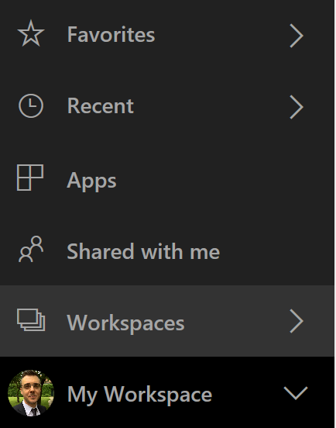

*The* ***Navigation Pane*** *can be used to move between the Power BI building blocks, consisting of Dashboards, Reports, and Datasets.*

*A* ***Dashboard*** *is a single canvas that contains one or more tiles, and each tile displays a single visualization that was created from the data in the underlying datasets. Dashboards can be shared with other users.*

*A* ***Report*** *consists of one or more pages of visualizations (charts, graphics, and more.). Reports can be created from scratch or can be imported with datasets.*

*A* ***Dataset*** *is a resource that can be connected to, and that is used to create reports*

### Connecting to a Power BI Desktop File

In this task, you will upload a Power BI Desktop file. ~

1. In the **Navigation Pane**, click **Get Data** (located at the bottom of the pane).



1. In the **Get Data** page, inside the **Files** tile, click **Get**.

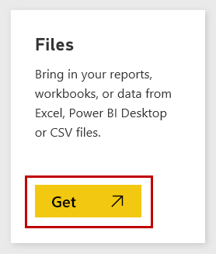

1. Click the **Local File** tile.

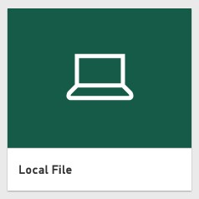

1. In the **Choose File to Upload** window, navigate to the **E:\Labs\Lab 1\** folder.
2. Select the **US Sales Analysis.pbix** file, and then click **Open**.

*This is the Power BI Desktop file that was created in lab 1.*

1. When the file has uploaded, in the **Navigation Pane,** on the center of the screen, notice the addition of the **US Sales Analysis** dashboard, report and dataset.

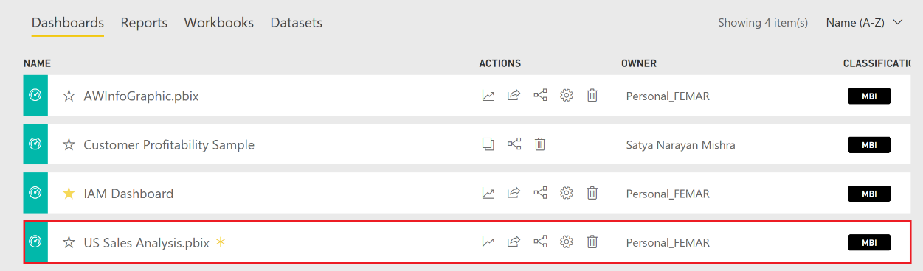

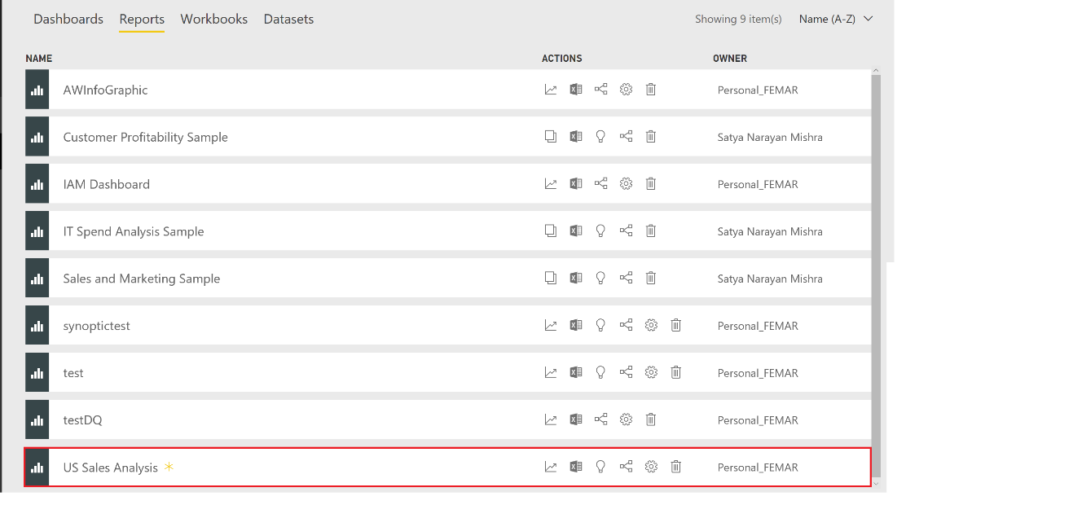

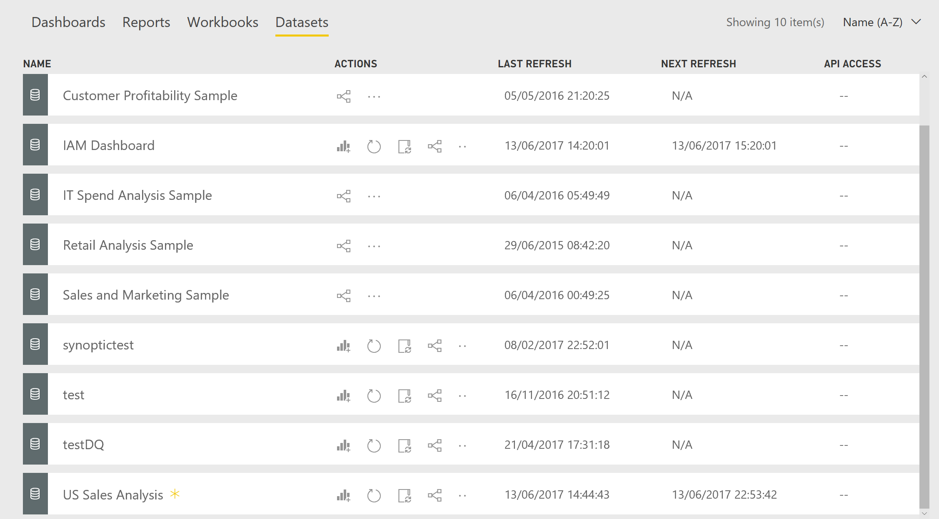

*The Power BI Desktop file contains both a model and a report. In Power BI, the model is now expressed as a dataset.*

1. In the dashboard “US Sales Analysis.pbix” click the settings option to change its name to **Tailspin Toys CY2015**:



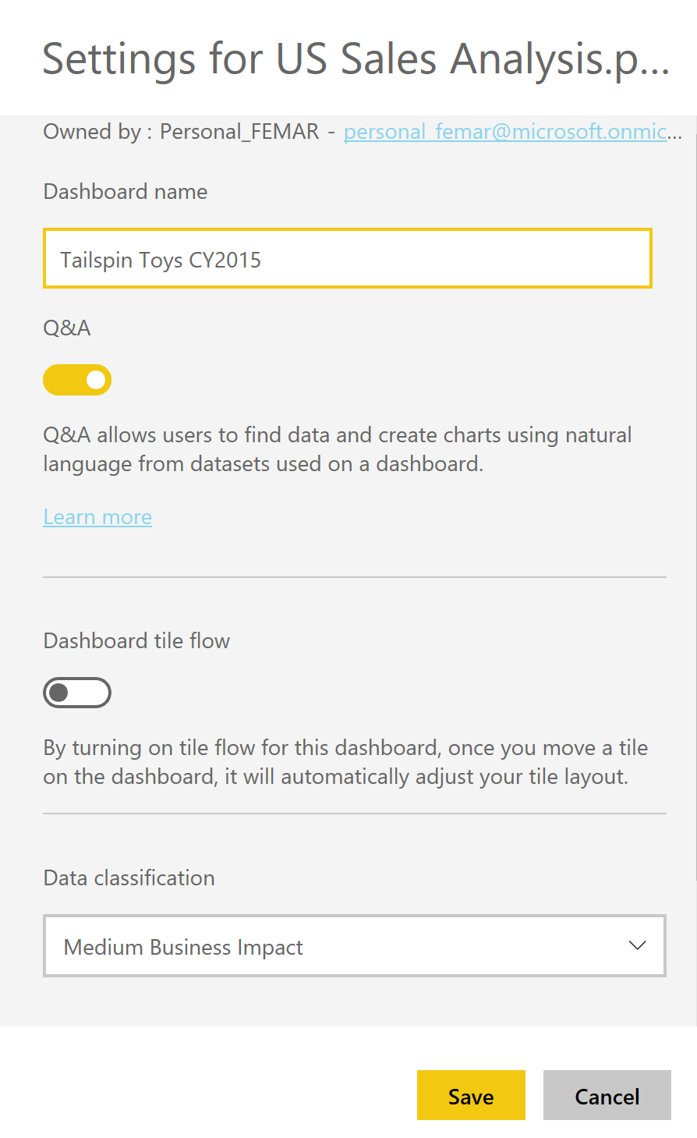

Click **Save** to complete the operation.

1. Next, open the dashboard, by clicking its name and notice the **US Sales Analysis.pbix** tile.

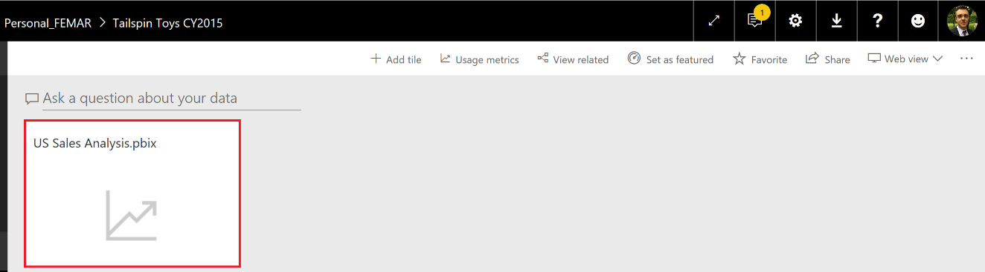

*The tile defines a relationship between the dashboard and the dataset, and will be the resource queried when asking Q&A questions. Additionally, clicking the tile can quickly enable browsing the report based on the dataset.*

### Creating a Featured Question

In this task, you will create a featured question to assist users when using Q&A with the **US Sales Analysis** dataset.

1. At the top-right corner, click the **Settings** command (cog), and then select **Settings**.

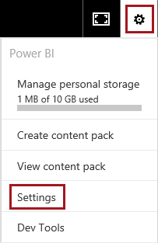

1. Select the **Datasets** tab.

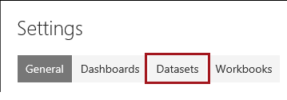

1. Ensure that the **US Sales Analysis** dataset is selected.

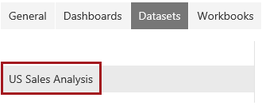

1. Expand **Featured Q&A Questions**.
2. Click the **Add a Question** link.

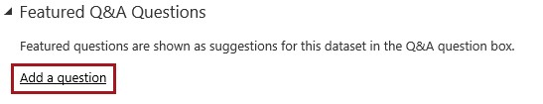

1. In the box, enter **Show total net revenue**.

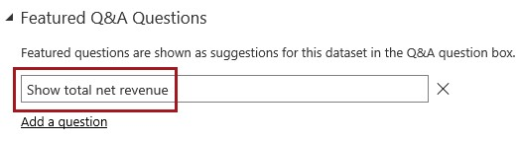

1. Click **Apply**.
2. Reload the web page by pressing F5. Ignore any errors that might appear related to the gateway and data source credentials.

**Exercise 3: Assembling a Power BI Dashboard**

### Introduction

In this exercise, you will assemble a dashboard by creating tiles sourced from Q&A questions, and also from new and existing report visualizations.

### Objectives

* Learn how to assemble a dashboard using Q&A and report visualizations.

### Creating Dashboard Tiles from Q&A Responses

In this task, you will create dashboard tiles by using Q&A.

1. In the **Navigation Pane**, select the **Tailspin Toys CY2015** dashboard.
2. Click the **Q&A** box (Ask a question about your data).



1. Select the **Show total net revenue** suggestion.



*Featured questions not only provide suggestions, but can also fast track entering common questions.*

1. Review the Q&A response.

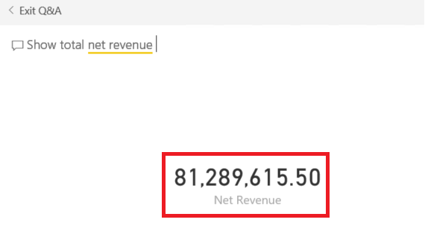

1. Beneath the response, notice the data source, which is the **US Sales Analysis** dataset.



1. In the Q&A box, modify the question to **Show total net revenue where year is CY2015**.
2. Verify that the value updates to **30,388,941**.
3. To create a dashboard tile for this question, to the right of the Q&A box, click the **Pin Visual** icon on the top-right corner:



1. In the **Pin to Dashboard** dialog window, notice the ability to pin the visual to a new or existing dashboard, and then click **Pin** to add a tile to the existing dashboard.

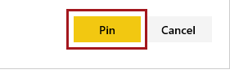

*In this lab, you will work with a single dashboard.*

1. To return to the dashboard page, click the back arrow.



1. On the dashboard page, notice the **Net Revenue** tile.

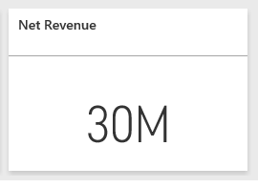

1. To modify the tile title, hover the cursor over the tile, and then click the ellipsis when it appears.

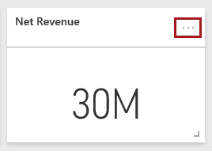

1. Click the **Edit Tile** icon.

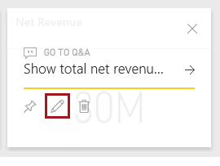

1. In the **Tile Details** pane (located at the right), in the **Title** box, modify the text to **YTD Net Revenue**.

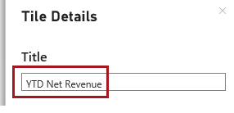

1. Click **Apply**.
2. Verify that the title of the tile has updated.

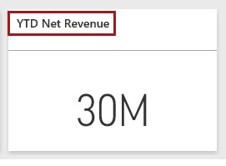

1. To return to the source question for the tile, simply click the tile.
2. To produce a variation of the question, in the Q&A box, modify the question as follows.



1. In the bar chart response, notice that the months are sorted in descending net revenue order.
2. To sort by month, modify the question as follows.



1. To further customize the response, expand the **Visualizations** pane (located at the right).

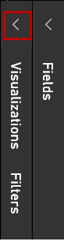

1. To change the visualization type, select **Line Chart**.

*Tip: Hovering over a visualization type icon will reveal a tooltip that describes the visualization type.*

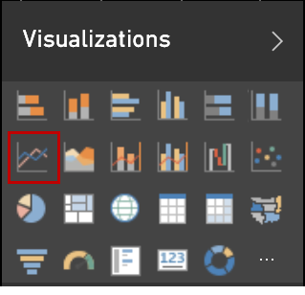

1. To modify the chart format, switch to the Format view.



1. Expand the **Data Colors** section, and then in the **Net Revenue** dropdown list, select **Purple**.

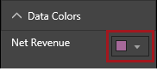

1. Pin the visualization to the existing dashboard, and then return to the dashboard.
2. To resize the new tile, hover the cursor over the tile, and then drag the bottom-right corner toward the top-left corner, and then release when the tile size matches the height of the other tiles, and is also three times wider than them (that is 1x3).

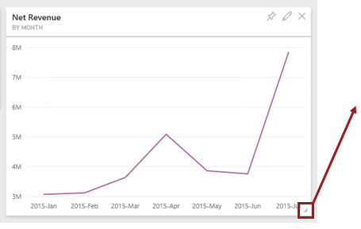

1. Verify that the dashboard layout looks similar to the following screenshot.

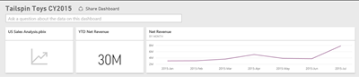

### Creating Dashboard Tiles from Existing Visualizations

In this task, you will create dashboard tiles by using existing visualizations from the **US Sales Analysis** report.

1. In the dashboard, click the **US Sales Analysis.pbix** tile.

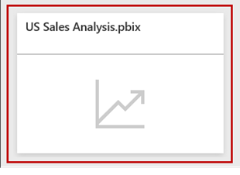

*The report consists of two pages, and was created in Power BI Desktop.*

1. Go to the US Sales page. Hover the cursor over the Tailspin Toys logo, and then click the **Pin Visual** icon.

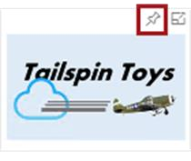

1. In the **Pin to Dashboard** dialog window, click **Pin to Existing Dashboard**.
2. In the **Year** slicer (located at the left), ensure that the report page is filtered only by **CY2015**.

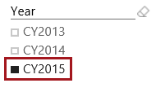

1. To zoom into the **Net Revenue, Cost and Profitability by Month** visualization, hover the cursor over the chart, and then click the **Pop Out** icon.

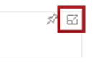

1. Pin the **Net Revenue, Cost and Profitability by Month** visualization (combo chart) to the dashboard.
2. To revert the chart to normal size, click the **Back to Report** option.



1. Pin also the first table, located on the left, to the dashboard.
2. To return to the dashboard, in the **Navigation Pane**, select the **Tailspin Toys CY2015** dashboard.
3. In the dashboard page, resize the Tailspin Toys logo tile to the smallest possible size (that is 1x1).
4. Reposition the tiles to produce the following dashboard layout.

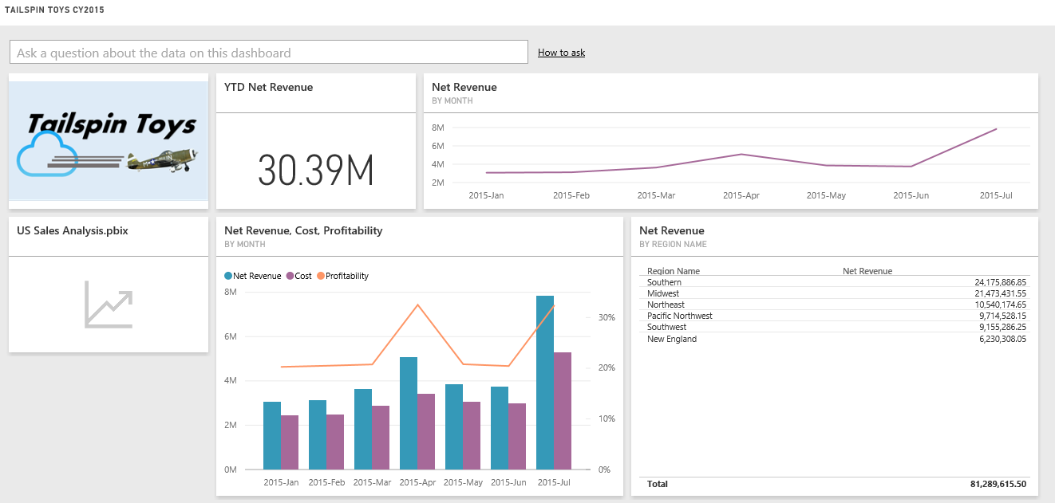

1. Click the ellipsis for the **Net Revenue, Cost, Profitability** tile, and then click the **Edit** icon.

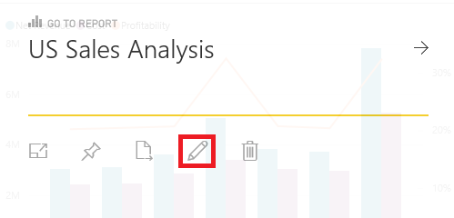

1. Set the **Display last refresh time** functionality.

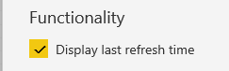

1. Click **Apply**.
2. Observe the last refresh time information, which indicates the last time the dataset that is providing data to this visualization, was refreshed.



### Creating a Report Page

In this task, you will create a report page consisting of new visualizations that you will also pin to the dashboard.

1. To add a new page to the report, navigate to the report again by clicking the **US Sales Analysis.pbix** tile.

*In this task, there is no need to enable custom visuals.*

1. To edit the report, on the report menu, at the top, click **Edit Report**.



1. To insert a new report page, at the bottom-left corner, click **Add Page (+)**.



1. To name the page, double-click **Page 1**.
2. Replace the text with **Additional Dashboard Visuals**, and then press Enter.



1. To filter the report page, in the **Fields** pane, expand the **Date** table.

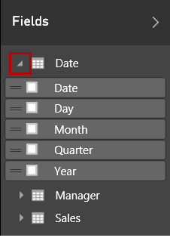

1. From inside the **Date** table, drag the **Year** field, and drop it into the **Page Level Filters** well.

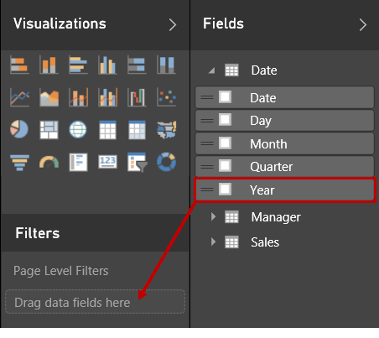

1. Select the **CY2015** check box.

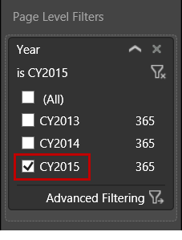

*All data expressed on the report page will now be filtered by* ***CY2015****.*

1. In the **Fields** pane, expand the **Sales** table, and then drag the **Quantity** field and drop it at the top-left corner of the canvas.

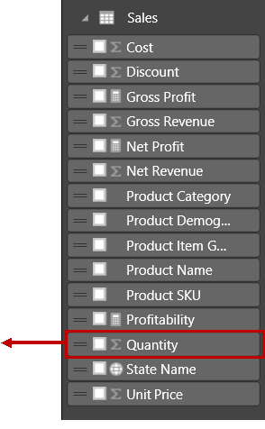

1. Change the visualization type to **Card**.

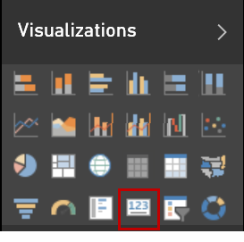

1. Resize and reposition the visualization as follows.



1. To create a new visualization, drag the **Sales | Quantity** field and drop it at the right of the card visualization.
2. Drag the **Date | Month** field and drop it inside the new visualization.
3. Change the visualization to **Line Chart**.

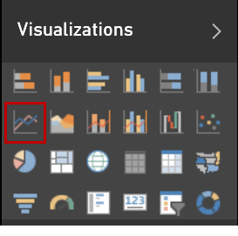

1. To modify the sort order, click the ellipsis located at the top right corner, click the **Sort By** down arrow, and then select **Month**.
2. To sort by month ascending, click the ellipsis again, and then click the **AZ** icon.



1. Resize and reposition the visualization as follows.

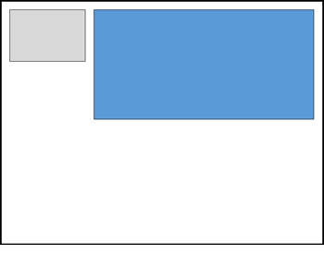

1. Create a treemap visualization by using the **Manager | Region Name** and the **Sales | Net Revenue** fields, and the resize and reposition the visualization as follows.

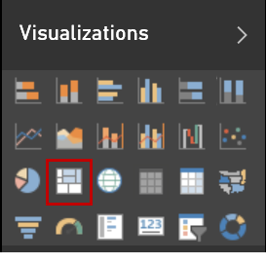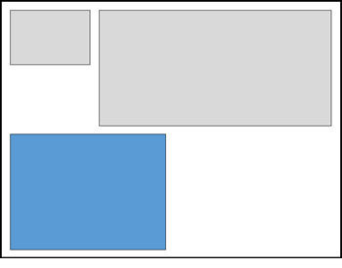

1. Verify that the visualization looks similar to the following screenshot.

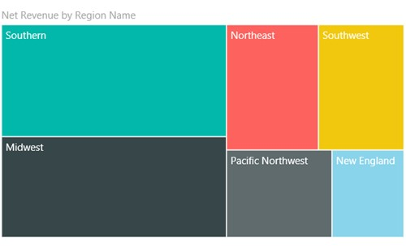

1. Create a map visualization by using the **Sales | State Name** and the **Sales | Net Revenue** fields, and then resize and reposition the visualization as follows.

*There is no need to change the visualization type because map is the default type used when a spatial field such as* ***State Name*** *is used.*

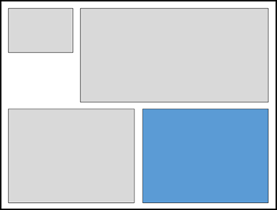

1. To display pie charts, drag the **Product | Product Item Group** field and drop it inside the **Legend** well.

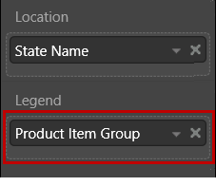

1. Notice the addition of a legend.

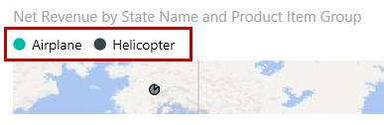

1. To display only the contiguous US states, in the **Filters** section (in the **Visualizations** pane, you might need to scroll down to locate the section), click **State Name (All)** to expand the filter list.

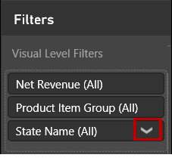

1. Check **(All)**, and then clear the **Alaska** and **Hawaii** check boxes.
2. If necessary, use the mouse wheel to adjust the zoom to fill the available visual space.
3. Verify that the visualization looks similar to the following screenshot.

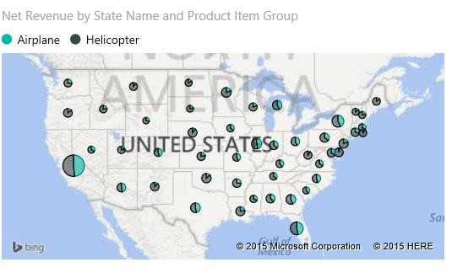

1. To save the report, at the right corner, click **File**,andthen select **Save**.

1. Pin each of the four visualizations to the dashboard.

### Completing the Dashboard Layout

In this task, you will finalize the dashboard layout.

1. Switch to the dashboard.
2. Modify the **Quantity** tile title to **YTD Quantity**.
3. Click the **YTD Quantity** title, and notice that it navigates to the source report page.
4. Return to the dashboard.
5. Resize the **Quantity BY MONTH** tile to a size 1x3 (similar to the **Net Revenue BY MONTH** tile).
6. Reposition the tiles to produce the following dashboard layout.

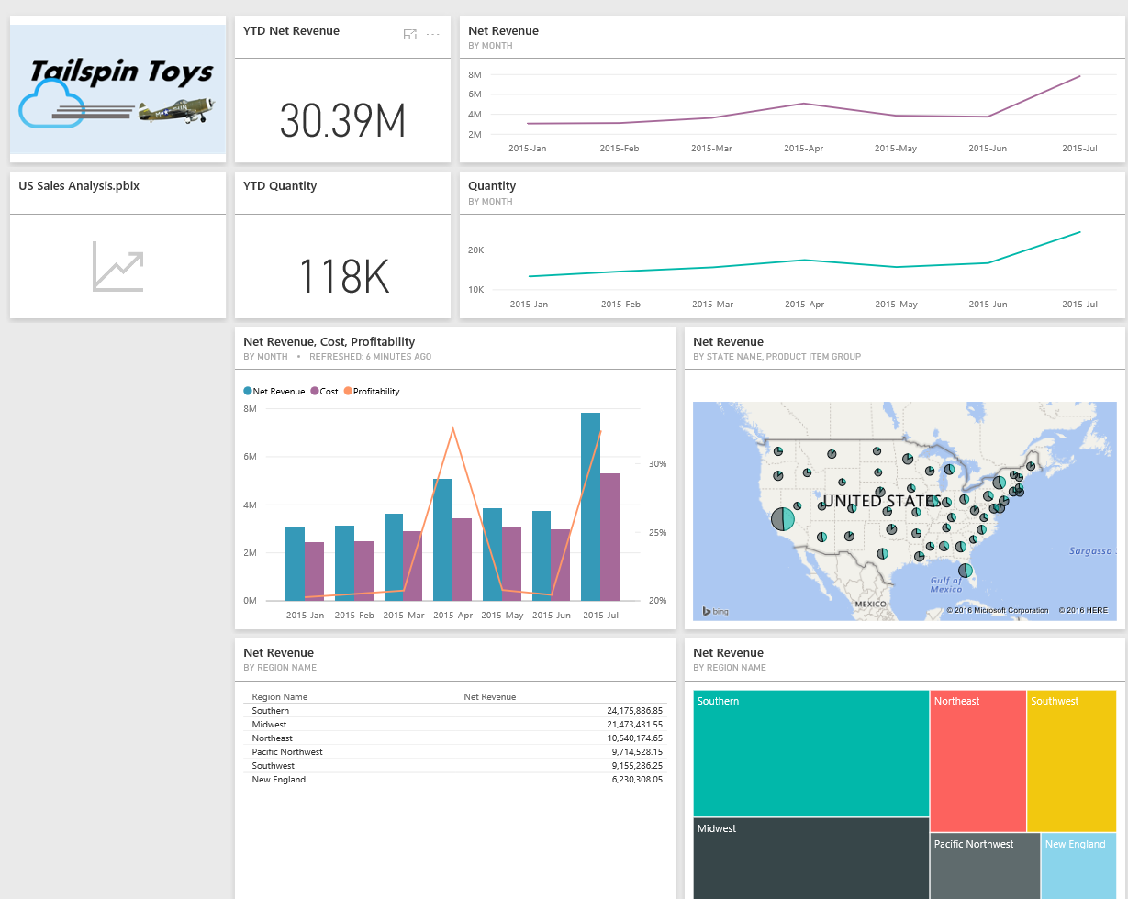

*The dashboard enables viewing data with a variety of different visualization types in a single pane of glass. Users can interact by entering new questions in the Q&A box, or by clicking on any tile to drill through to the tile source, which can be either a Q&A question, or a visualization saved within a report. Finally, dashboard pages can be shared with other registered Power BI users.*

### Exploring the Dashboard View

In this task, you will explore dashboard full screen mode.

1. To view the dashboard in full screen mode, click **Enter Full Screen Mode**.



1. If all tiles are still not visible, move the cursor toward the bottom-right corner, and when the pane appears, click **Fit to Screen**.



1. To exit the full screen mode, click **Exit Full Screen Mode**.



### Sharing the Dashboard

In this task, you will explore how to share the dashboard. This step does require a PRO license or TRIAL.

1. At the right of the dashboard title, click **Share**.



1. In the **Share Dashboard** page, notice that, as the dashboard owner, you can manage sharing this dashboard to other users who have the same email domain as you or even external users.

*Sharing provides access to the dashboard and reports in the reading view, which means they can interact, but not change the layout of the dashboard or reports.*

*Users will find the dashboard in their* ***My Workspace****, annotated with the sharing icon. They will not see the dataset that it uses.*